Math 321- Michael Streyle

## Problem 44

# n=5,   
x=rweibull(n = 5, shape = 2, scale = 5)  
samp = sample(x, size = 5*1000, replace=T)  
  
sampmatrix = matrix(samp, 5)  
sampmeans = apply(sampmatrix, 2, mean)  
hist(sampmeans, main='Problem 44, n=5')

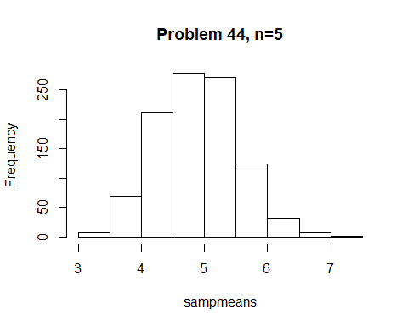

# n=10,   
x10=rweibull(n = 10, shape = 2, scale = 5)  
samp10 = sample(x10, size = 10*1000, replace=T)  
  
sampmatrix10 = matrix(samp10, 10)  
sampmeans10 = apply(sampmatrix10, 2, mean)  
hist(sampmeans10, main='Problem 44, n=10')

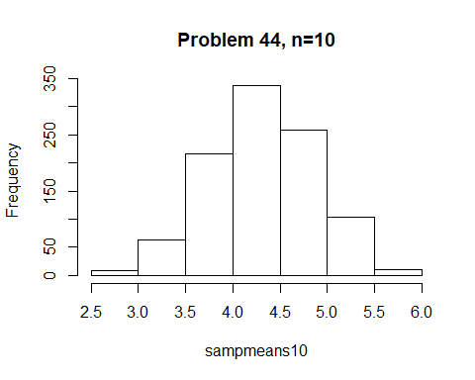

# n=20,   
x20=rweibull(n = 20, shape = 2, scale = 5)  
samp20 = sample(x20, size = 20*1000, replace=T)  
  
sampmatrix20 = matrix(samp20, 20)  
sampmeans20 = apply(sampmatrix20, 2, mean)  
hist(sampmeans20, main='Problem 44, n=20')

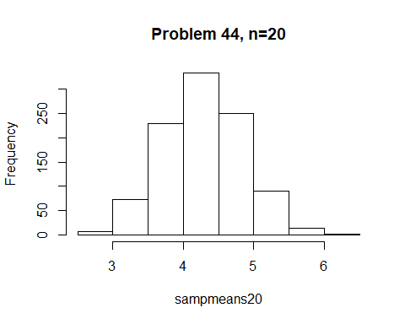

# n=30,   
x30=rweibull(n = 30, shape = 2, scale = 5)  
samp30 = sample(x30, size = 30*1000, replace=T)  
  
sampmatrix30 = matrix(samp30, 30)  
sampmeans30 = apply(sampmatrix30, 2, mean)  
hist(sampmeans30, main='Problem 44, n=30')

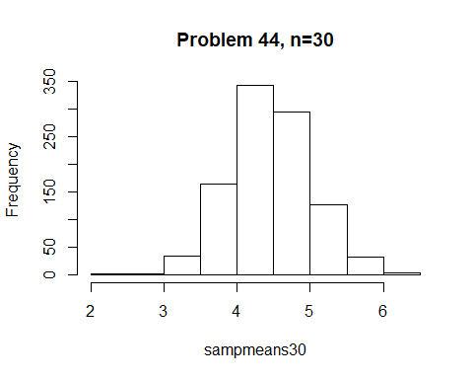

## Problem 45.

#n=10  
  
x.10=rnorm(n = 10, mean = 3, sd = 1)  
samp.10 = sample(x.10, size = 10*1000, replace=T)  
  
sampmatrix.10 = matrix(samp.10, 10)  
sampmeans.10 = apply(sampmatrix.10, 2, mean)  
hist(sampmeans.10, main='Problem 45, n=10')

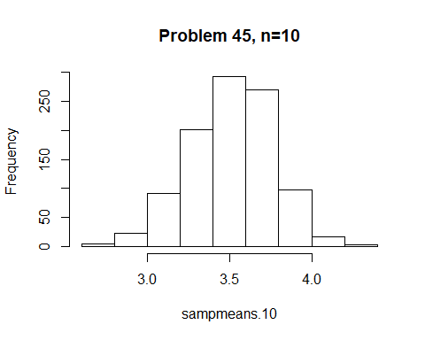

#n=20  
  
x.20=rnorm(n = 20, mean = 3, sd = 1)  
samp.20 = sample(x.20, size = 20*1000, replace=T)  
  
sampmatrix.20 = matrix(samp.20, 20)  
sampmeans.20 = apply(sampmatrix.20, 2, mean)  
hist(sampmeans.20, main='Problem 45, n=20')

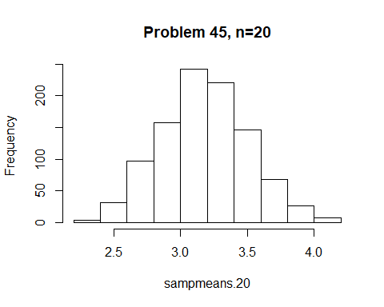

#n=30  
  
x.30=rnorm(n = 30, mean = 3, sd = 1)  
samp.30 = sample(x.30, size = 30*1000, replace=T)  
  
sampmatrix.30 = matrix(samp.30, 30)  
sampmeans.30 = apply(sampmatrix.30, 2, mean)  
hist(sampmeans.30, main='Problem 45, n=30')

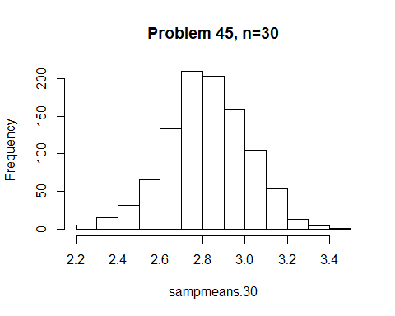

#n=50  
  
x.50=rnorm(n = 50, mean = 3, sd = 1)  
samp.50 = sample(x.50, size = 50*1000, replace=T)  
  
sampmatrix.50 = matrix(samp.50, 50)  
sampmeans.50 = apply(sampmatrix.50, 2, mean)  
hist(sampmeans.50, main='Problem 45, n=50')

